**DATA SCIENCE & MACHINE LEARNING**

**Cycle 2**

**1.Create a three dimensional array specifying float data type and print it.**

>>

import numpy as np

arr=np.array([[[1, 2, 3], [4, 5, 6]], [[7, 2, 3], [9, 5, 6]]],dtype='f')

print(arr)

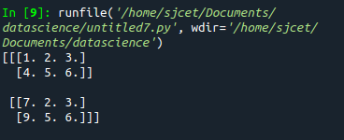

**2.Create a 2 dimensional array (2X3) with elements belonging to complex data**

**type and print it. Also display**

**a. the no: of rows and columns**

**b. dimension of an array**

**c. reshape the same array to 3X2**

>>

import numpy as np

array = np.array([[1,3,5], [3, 4,6]],dtype ="complex")

print(array)

print("no of rows and column",array.shape)

narr = array.reshape(3,2)

print("reshape\n",narr)

print("dimension\n",array.ndim)

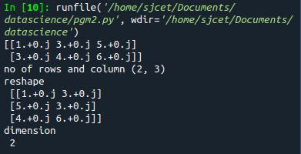

**3.Familiarize with the functions to create**

**a) an uninitialized array**

**b) array with all elements as 1,**

**c) all elements as 0**

**>>**

import numpy as np

#1

print(np.empty(2))

#2

print(np.ones(5))

#3

a=(3,2)

print(np.zeros(a))

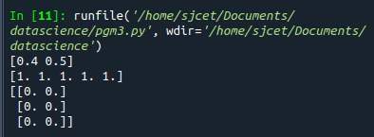

**4.Create an one dimensional array using arange function containing 10 elements.**

**Display**

**a. First 4 elements**

**b. Last 6 elements**

**c. Elements from index 2 to 7**

>>

import numpy as np

print(np.arange(1,11,1))

#1

print(np.arange(1,5,1))

#2

print(np.arange(5,11,1))

#3

print(np.arange(2,7,1))

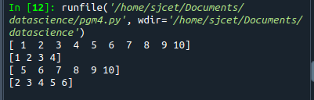

**5.Create an 1D array with arange containing first 15 even numbers as elements**

**a. Elements from index 2 to 8 with step 2(also demonstrate the same**

**using slice function)**

**b. Last 3 elements of the array using negative index**

**c. Alternate elements of the array**

**d. Display the last 3 alternate elements**

**>>**

import numpy as np

a = np.arange(0,15,2)

print(a)

print("Elements from index 2 to 8 ")

print(a[2:8:2])

print("last 3 elements using -ve index :",a[-3:])

print("Alternate elements:",a[-5::2])

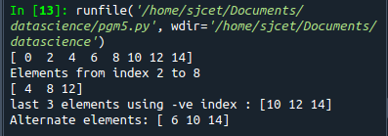

**6.Create a 2 Dimensional array with 4 rows and 4 columns.**

**a. Display all elements excluding the first row**

**b. Display all elements excluding the last column**

**c. Display the elements of 1 st and 2 nd column in 2 nd and 3 rd row**

**d. Display the elements of 2 nd and 3 rd column**

**e. Display 2 nd and 3 rd element of 1 st row**

**f. Display the elements from indices 4 to 10 in descending order(use**

**–values)**

>>

import numpy as np

x =np.arange(1,33,2).reshape(4,4)

print(x)

print("Excluding first row :",x[1:])

print("Excluding last column :",x[:, :3])

print("Elements of 2nd and 3rd column:",x[:,1:3])

print("Elements of 1st and 2nd column in 2nd and 3rd row:",x[1:3,:2])

print("2nd and 3rd elements of 1st row:",x[:1,1:3])

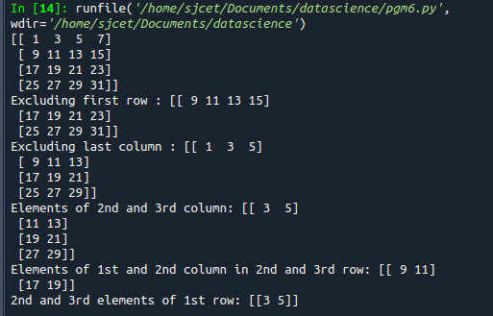

**7.Create two 2D arrays using array object and**

**a. Add the 2 matrices and print it**

**b. Subtract 2 matrices**

**c. Multiply the individual elements of matrix**

**d. Divide the elements of the matrices**

**e. Perform matrix multiplication**

**f. Display transpose of the matrix**

**g. Sum of diagonal elements of a matrix**

>>

import numpy as np

x1=np.arange(1,5,1).reshape((2,2))

x2=np.arange(1,5,1).reshape((2,2))

#1

a=np.add(x1,x2)

print("The addition result",a)

#2

a=np.subtract(x1,x2)

print("The substract value is",a)

#3

a=np.multiply(x1,x2)

print("The mulitiplication of individual elements",a)

#4.

a=np.divide(x1,x2)

print("The division of individual element",a)

#5.

a=np.matmul(x1,x2)

print("The result is",a)

#6.

a=x1.transpose()

print("The transpose is",a)

#7.

a=np.trace(x1)

print("The sum of diagonal elements",a)

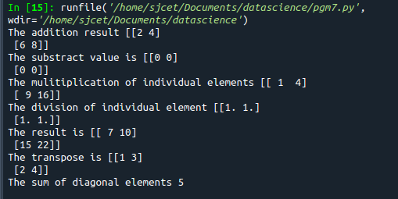

**8.Demonstrate the use of insert() function in 1D and 2D array.**

>>

import numpy as np

arr1 = np.arange(10, 16)

print("1D ARRAY ")

print("The array is: ", arr1)

obj = 2

value = 40

arr = np.insert(arr1, obj, value, axis=None)

print("After inserting the new array is: ")

print(arr)

print("Shape of the new array is : ", np.shape(arr))

print("2D ARRAY ")

arr1 = np.array([(1, 2, 3), (4, 5, 6), (7, 8, 9), (50, 51, 52)])

print("The array is: ")

print(arr1)

print("The shape of the array is: ", np.shape(arr1))

a = np.insert(arr1, 1, [[50], [100], ], axis=0)

print("New array is : ")

print(a)

print("Shape of the array is: ", np.shape(a))

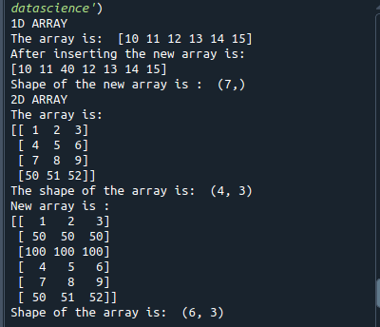

**9.Demonstrate the use of diag() function in 1D and 2D array.**

>>

import numpy as np

a= np.array([[3, 6,7,8]])

b=np.array([[3, 6,8,7], [4, 2,1,0],[3,1,3,3],[1,1,2,2]])

x=np.diag(a)

y=np.diag(b)

print(x)

print(y)

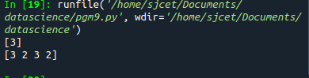

10.**Demonstarte the use of append() function in 1D and 2D**

**array.**

>>

import numpy as np

a = np.array([[1,2,3],[4,5,6]])

b=np.array([1,2,3])

print("First array:")

print (a)

print("Second array")

print(b)

print ("\n")

print ("Append elements to array:")

print (np.append(a, [7,8,9]).reshape(3,3))

print (np.append(b, [7,8,9]))

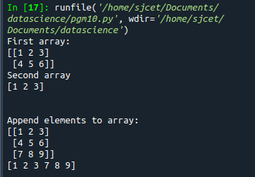

11.**Demonstarte the use of sum() function in 1D and 2D array.**

>>

import numpy as np

a=np.array([0.4,0.5])

b=np.sum(a)

print (b)

